The Five Stages of Project Team Development

BY [PROJECT-MANAGEMENT.COM](https://project-management.com/author/admin/) · NOVEMBER 25, 2016

Every team goes through the five stages of team development. The first four stages of team growth were first developed by Bruce Wayne Tuckman and published in 1965. His theory, called “Tuckman’s Stages” was based on research he conducted on team dynamics. He believed (as is a common belief today) that these stages are inevitable in order for a team to grow to the point where they are functioning effectively together and delivering high quality results. In 1977, Tuckman, jointly with Mary Ann Jensen, added a fifth stage to the 4 stages: “Adjourning.” The adjourning stage is when the team is completing the current project. They will be joining other teams and moving on to other work in the near future. For a high performing team, the end of a project brings on feelings of sadness as the team members have effectively become as one and now are going their separate ways.

The five stages:

* Stage 1: Forming
* Stage 2: Storming
* Stage 3: Norming
* Stage 4: Performing
* Stage 5: Adjourning

This article provides background on each stage and an example of a team going through all five stages.

Stage 1: Forming

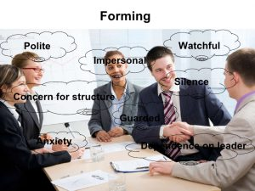The “forming” stage takes place when the team first meets each other. In this first meeting, team members are introduced to each. They share information about their backgrounds, interests and experience and form first impressions of each other. They learn about the project they will be working on, discuss the project’s objectives/goals and start to think about what role they will play on the project team. They are not yet working on the project. They are, effectively, “feeling each other out” and finding their way around how they might work together.

During this initial stage of team growth, it is important for the team leader to be very clear about team goals and provide clear direction regarding the project. The team leader should ensure that all of the members are involved in determining team roles and responsibilities and should work with the team to help them establish how they will work together (“team norms”.) The team is dependent on the team leader to guide them.

Stage 2: Storming

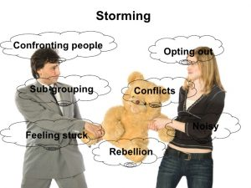As the team begins to work together, they move into the “storming” stage. This stage is not avoidable; every team – most especially a new team who has never worked together before – goes through this part of developing as a team. In this stage, the team members compete with each other for status and for acceptance of their ideas. They have different opinions on what should be done and how it should be done – which causes conflict within the team. As they go progress through this stage, with the guidance of the team leader, they learn how to solve problems together, function both independently and together as a team, and settle into roles and responsibilities on the team. For team members who do not like conflict, this is a difficult stage to go through.

The team leader needs to be adept at facilitating the team through this stage – ensuring the team members learn to listen to each other and respect their differences and ideas. This includes not allowing any one team member to control all conversations and to facilitate contributions from all members of the team. The team leader will need to coach some team members to be more assertive and other team members on how to be more effective listeners.

This stage will come to a closure when the team becomes more accepting of each other and learns how to work together for the good of the project. At this point, the team leader should start transitioning some decision making to the team to allow them more independence, but still stay involved to resolve any conflicts as quickly as possible.

Some teams, however, do not move beyond this stage and the entire project is spent in conflict and low morale and motivation, making it difficult to get the project completed. Usually teams comprised of members who are professionally immature will have a difficult time getting past this stage.

Stage 3: Norming

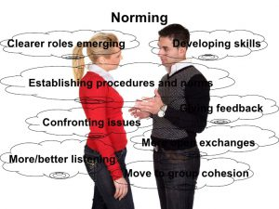When the team moves into the “norming” stage, they are beginning to work more effectively as a team. They are no longer focused on their individual goals, but rather are focused on developing a way of working together (processes and procedures). They respect each other’s opinions and value their differences. They begin to see the value in those differences on the team. Working together as a team seems more natural. In this stage, the team has agreed on their team rules for working together, how they will share information and resolve team conflict, and what tools and processes they will use to get the job done. The team members begin to trust each other and actively seek each other out for assistance and input. Rather than compete against each other, they are now helping each other to work toward a common goal. The team members also start to make significant progress on the project as they begin working together more effectively.

In this stage, the team leader may not be as involved in decision making and problem solving since the team members are working better together and can take on more responsibility in these areas. The team has greater self-direction and is able to resolve issues and conflict as a group. On occasion, however, the team leader may step in to move things along if the team gets stuck. The team leader should always ensure that the team members are working collaboratively and may begin to function as a coach to the members of the team.

Stage 4: Performing

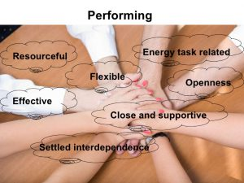In the “performing” stage, teams are functioning at a very high level. The focus is on reaching the goal as a group. The team members have gotten to know each other, trust each other and rely on each other.

Not every team makes it to this level of team growth; some teams stop at Stage 3: Norming. The highly performing team functions without oversight and the members have become interdependent. The team is highly motivated to get the job done. They can make decisions and problem solve quickly and effectively. When they disagree, the team members can work through it and come to consensus without interrupting the project’s progress. If there needs to be a change in team processes – the team will come to agreement on changing processes on their own without reliance on the team leader.

In this stage, the team leader is not involved in decision making, problem solving or other such activities involving the day-to-day work of the team. The team members work effectively as a group and do not need the oversight that is required at the other stages. The team leader will continue to monitor the progress of the team and celebrate milestone achievements with the team to continue to build team camaraderie. The team leader will also serve as the gateway when decisions need to be reached at a higher level within the organization.

Even in this stage, there is a possibility that the team may revert back to another stage. For example, it is possible for the team to revert back to the “storming” stage if one of the members starts working independently. Or, the team could revert back to the “forming” stage if a new member joins the team. If there are significant changes that throw a wrench into the works, it is possible for the team to revert back to an earlier stage until they are able to manage through the change.

Stage 5: Adjourning

In the “adjourning” stage the project is coming to an end and the team members are moving off into different directions. This stage looks at the team from the perspective of the well-being of the team rather than from the perspective of managing a team through the original four stages of team growth.

The team leader should ensure that there is time for the team to celebrate the success of the project and capture best practices for future use. (Or, if it was not a successful project – to evaluate what happened and capture lessons learned for future projects.) This also provides the team the opportunity to say good-bye to each other and wish each other luck as they pursue their next endeavor. It is likely that any group that reached Stage 4: Performing will keep in touch with each other as they have become a very close knit group and there will be sadness at separating and moving on to other projects independently.